

**MGM’s POLYTECHNIC, AURANGABAD**

**2020-2021**

Micro Project Report

On

**“Make the report on Pressure welding and its type”**

Submitted in partial fulfillment for ‘I’ Scheme forth semester of

**Diploma in**

**MECHANICALENGINEERING**

**By**

**DHAKNE RAMAKANT MAHENDRA ( 1915010275 )**

**MOHAMMED SAAD SAYYED ( 1915010276 )**

**JADHAV SWARAJ MILIND ( 1915010277 )**

Under the guidance of

**Prof. Parbhane U.M**

(Lecturer in Mechanical Engineering)

***In Pursuit of Excellence***



[**Maharashtra State Board of Technical Education, Mumbai**](http://msbte.org.in/)

**(Autonomous) (ISO-9001-2008) (ISO/IEC 27001:2013)**



**Maharashtra State**

**Board of Technical Education, Mumbai**

**Certificate of Completion**

This is to certify that**, MOHAMMED SAAD SAYYED** with Enrollment No: **1915010276 ,** have successfully completed their Micro-Project entitled **“Make the report on Pressure welding and its type”** in the Course/Subject of **"22438 - Theory of Machines”**in the forth semester during thier tenure of completing the Diploma programme in **Mechanical Engineering** From **MGM's Polytechnic** institute with institute code **1501.**

**Prof. Parbhane U.M Prof. Bhalekar B.D**

**Course Coordinator HOD**

Mechanical Engineering Mechanical Engineering

**Dr. B. M. Patil**

**Principal**

**INDEX**

|  |  |  |
| --- | --- | --- |
| **Sr. No.** | **Content** | **Page No.** |
| **Micro-Project Proposal (ANNEXURE-I)** | |  |
| 1.0 | Aims/Benefits of the Micro-Project | 4 |
| 2.0 | Course Outcomes Addressed | 4 |
| 3.0 | Proposed Methodology | 4 |
| 4.0 | Action Plan | 4 |
| 5.0 | Resources Required | 5 |
|  |  |  |
| **Micro-Project Report (ANNEXURE-II)** | |  |
| 1.0 | Rationale | 6 |
| 2.0 | Aims/Benefits of the Micro-Project | 6 |
| 3.0 | Course Outcomes Achieved | 6 |
| 4.0 | Literature Review | 6 |
| 5.0 | Actual Methodology Followed | 15 |
| 6.0 | Actual Resources Used | 15 |
| 7.0 | Outputs of the Micro-Projects | 16 |
| 8.0 | Skill Developed / Learning outcomes of this Micro-Project | 16 |
| 9.0 | Applications of this Micro-Project | 16 |

**Annexure – I**

**Micro-Project Proposal**

**Make the report on Pressure welding and its type**

1. **Aims/Benefits of the Micro-Project**

We learn what is pressure welding and its types and also see how to use it in different industries. Pressure welding stands for a group of joining processes in which components are joined by applying heat and pressure.

**2.0 Course Outcomes Addressed**

* As the process is performed at ambient temperature, there are no thermal effects on the parts being joined, and the process is fast.
* It is simple and inexpensive to operate once dies have been produced. However, it is highly specialized with respect to joint design and materials to be welded..

**3.0 Proposed Methodology**

1. We will finalize micro project team.
2. We will finalize topic for micro project.
3. We will prepare certificate and proposal of report.
4. Then we will collect information based on Pressure welding and its type
5. We will prepare a Model on Pressure welding and its type
6. And we will make report based on micro project.
7. Then at last we will derive a chart on Pressure welding and its type

**4.0 Action Plan**

|  |  |  |  |  |
| --- | --- | --- | --- | --- |
| **S. No.** | **Details of activity** | **Planned Start date** | **Planned Finish date** | **Name of Responsible Team Members** |
|  | Finalization of Micro Project Team | 1 may 2021 | 2 may 2021 | Sayyed saad , swraj jadhav and ramakant dhakne |
|  | Finalization of Topic | 3 may 2021 | 4 may 2021 |
|  | Literature Survey | 5 may 2021 | 6 may 2021 | Sayyed saad , and ramakant dhakne |
|  | Submission of Micro-Project Proposal (ANNEXURE-I) | 7 may 2021 | 8 may 2021 | Sayyed saad , swraj jadhav and |
|  | Proposed Methodology | 8 may 2021 | 9 may 2021 | Sayyed saad , and ramakant dhakne |
|  | Collecting Resources Required (raw material) | 10 may 2021 | 10 may 2021 | Sayyed saad , swraj jadhav and |
|  | Making of Chart | 10 may 2021 | 10 may 2021 | Sayyed saad , swraj jadhav and ramakant dhakne |
|  | Submission of Micro-Project Report (ANNEXURE-II) | 10 may 2021 | 10 may 2021 | Sayyed saad , |
|  | Presentation via report to Institute | 10 may 2021 | 10 may 2021 | Sayyed saad , |

**5.0 Resources Required**

|  |  |  |  |  |
| --- | --- | --- | --- | --- |
| **S. No.** | **Name of Resource/material** | **Specifications** | **Qty.** | **Remarks** |
|  | Ms word | Report | 1 |  |
| 2 | Electronic hub | Information site | 1 |  |
| 3 | Laptop or computer | - | 1 |  |
| 4 | Wikipedia | For gathering information | - |  |
| 5 | Google | For downloading image | - |  |

**Name of Team Members Roll No’s:**

1. MOHAMMED SAAD SAYYED 22114

**\*\*\*\*\*\*\*\*\*\*\*\*\***

**Annexure – II**

**Micro-Project Report**

**Make the report on Pressure welding and its type**

**1.0 Rationale**

* Pressure welding uses friction or explosion to heat the joining section of metal workpieces and join them under pressure. The process is also called solid-state welding. Pressure welding is a generic term for welding methods that weld workpieces by applying mechanical pressure on the joining section (weld joint).
* The use of mechanical pressure allows numerical control of the process. Pressure welding has been used widely in FA (factory automation).
* Major methods include gas pressure welding, friction welding, resistance welding, diffusion welding, ultrasonic welding, and explosion welding. Friction stir welding (FSW), a variant of friction welding, has become increasingly popular. This process can improve joint efficiency by using a rotating tool to stir the base materials with rotational friction while applying strong pressure on the joining section.

**2.0 Aims/Benefits of the Micro-Project:**

* To study and Make the report on Pressure welding and its type
* To understand types of Pressure welding and its type

**3.0 Course Outcomes Achieved**

* Estimate Pressure welding and its type in machine components.
* Perform test to evaluate mechanical properties according to Indian Standard.

**4.0 Literature Review**

Pressure welding uses friction or explosion to heat the joining section of metal workpieces and join them under pressure. The process is also called solid-state welding. Pressure welding is a generic term for welding methods that weld workpieces by applying mechanical pressure on the joining section (weld joint).

The use of mechanical pressure allows numerical control of the process. Pressure welding has been used widely in FA (factory automation).

Major methods include gas pressure welding, friction welding, resistance welding, diffusion welding, ultrasonic welding, and explosion welding. Friction stir welding (FSW), a variant of friction welding, has become increasingly popular. This process can improve joint efficiency by using a rotating tool to stir the base materials with rotational friction while applying strong pressure on the joining section.

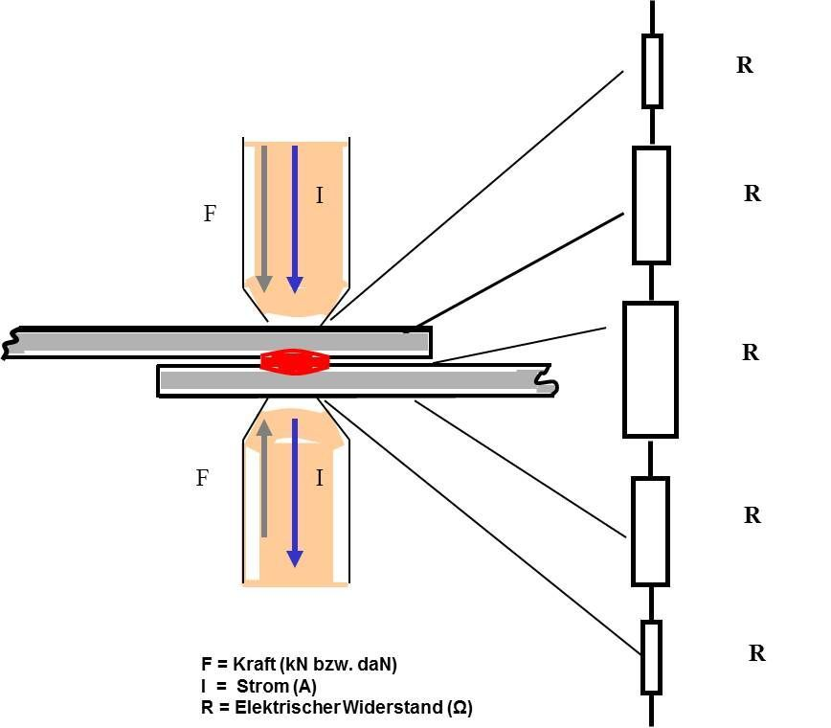

**Types of pressure welding**

* G**as pressure welding**

This method is often used to join steel frames for buildings. The joining surfaces of the [base materials](https://www.keyence.com/ss/products/measure/welding/glossary/#w15) are pressed against each other and the area is heated with acetylene gas and oxygen. When the base materials heat up and start melting, they are further pressed against each other. Impurities in the joining surfaces are pushed out and the surfaces are joined.

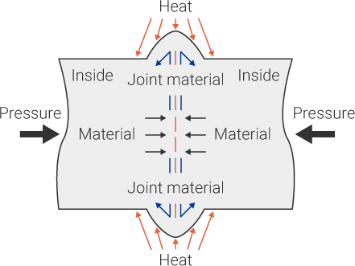

* **Friction welding**

Friction welding is considered environmentally friendly, making it a popular choice for factory automation. This page introduces friction stir welding (FSW), the technique for achieving excellent joint smoothness.

This method generates high-speed friction between the base materials (metal or resin) to soften them with the heat generated by the friction and then applies pressure to join them. It is said to be an eco-friendly joining method because it does not need a heat source other than friction heat, removes the need for welding rods or flux, and does not produce spatter or gas as compared to arc welding or gas welding.

Friction welding can be also performed based on three factors of friction thrust (pushing force), rotation speed and time. Since all of these can be controlled numerically, friction welding can be controlled automatically without human intervention and is widely used in FA (factory automation).

Friction stir welding (FSW), a variant of friction welding, has attracted a lot of attention. The process rotates a cylindrical tool with a probe (protrusion) at high speed and moves the tool so that the probe digs along the joining section with high pressure. The rotating tool softens the base materials and stirs the area around the weld to cause plastic deformation and atomic bonding between the materials.

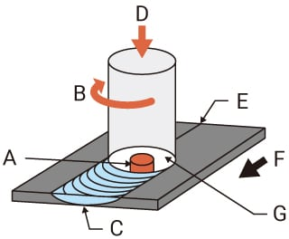

A) Probe

B) Rotation

C) Weld zone

D) Pressurization by the tool

E) Butt surfaces

F) Plate movement

G) Shoulder

* + **Resistance spot welding**

Weld materials are held together from above and below with copper electrodes for energization connected to the welding power supply. When a current passes through the section to be welded, the heat generated by electrical resistance (Joule heat) melts and joins the materials. In FA (factory automation), automatic resistant spot welding machines have been used widely in joining processes on manufacturing lines.

Seam welding, which uses a series of overlapping weld spots, and projection welding, which causes concentrated resistance heat on projections created on the joining surface of one material, are variations of resistant spot welding.

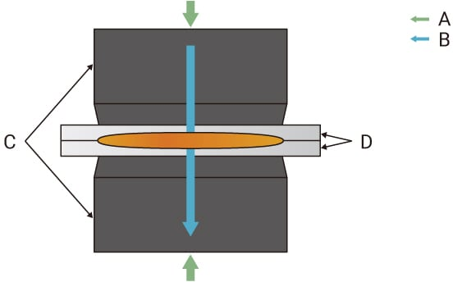

A) Pressure force

B) Flow of electric current

C) Electrodes

D) Weld materials

* + - **Projection welding**

Projection welding is often used to manufacture weld nuts and weld bolts. This page introduces projection welding, a method that adopts resistance welding principles. This method is broadly divided into two types: embossed projection welding and solid projection welding.

This method is used for welding nuts/bolts to steel plates. Electrodes for resistant spot welding are applied to the projection(s) provided on one of the base materials. Heat is concentrated on the projection(s) to soften the material and the welding starts. As the welding proceeds, the spot(s) becomes larger. Although this decreases the current density, the electrical resistance is increased by the raised temperature, which maintains high heat generation to allow welding. Consequently, the weld has high quality as compared to welding without using projections.

Projection welding is broadly divided into two types: Embossed projection welding and solid projection welding.

Embossed projection welding uses projections worked on the base material to concentrate current flow on the projections. Creating multiple projections allow simultaneous welding of multiple weld spots. Practical applications include welding gas tank reinforcements, shock absorber brackets, and oil filters. Unlike embossed projection welding, solid projection welding does not use projections created on a flat plate. It uses existing projections such as the corners of plates or crossed round bars. Practical applications include welding nuts and bolts on plates, or brake drums.

Embossed projection welding After welding

Embossed projection welding - Before welding Embossed projection welding - After welding

**Solid projection welding**

**Before welding After welding**

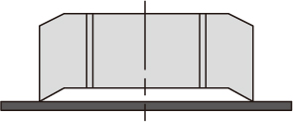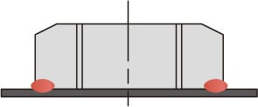

* **WHAT ARE THE ADVANTAGES AND DISADVANTAGES OF WELDING JOINTS?**

## ****ADVANTAGES OF WELDING JOINTS****

1. As no hole is required for welding, hence no reduction of area. So structural members are more effective in taking the load.
2. In welding filler plates, gusseted plates, connecting angles etc, are not used, which leads to reduced overall weight of the structure.
3. Welded joints are more economical as less labor and less material is required.
4. The efficiency of welded joint is more than that of the riveted joint.
5. The welded joints look better than the bulky riveted/butted joints.
6. The speed of fabrication is faster in comparison with the riveted joints.
7. Complete rigid joints can be provided with welding process.
8. The alternation and addition to the existing structure is easy.
9. No noise is produced during the welding process as in the case of riveting.
10. The welding process requires less work space in comparison to riveting.
11. Any space of joint can be made with ease.

**DISADVANTAGES OF WELDING JOINTS**

1. Welded joints are more brittle and therefore their fatigue strength is less than the members joined.
2. Due to uneven heating & cooling of the members during the welding, the members may distort resulting in additional stresses.
3. Skilled labor and electricity are required for welding.
4. No provision for expansion and contraction is kept in welded connection & therefore, there is possibility of racks.
5. The inspection of welding work is more difficult and costlier than the riveting work.
6. Defects like internal air pocket, slag inclusion and incomplete penetration are difficult to detect.

**5.0 Actual Methodology Followed**

1. We finalize a micro project team.
2. We finalize micro project topic based on syllabus.
3. We prepared proposal of micro project.
4. We distributed work of micro project into 3 team members as per their skills.
5. Collection of information/details required to was done by Saad Sayyed
6. Making of report was done by Saad Sayyed
7. Compose, typing and drafting of chart done by Ramakant Dhakne
8. Literature review is done by Sayyed Saad

**6.0 Actual Resources Used**

|  |  |  |  |  |
| --- | --- | --- | --- | --- |
| **S. No.** | **Name of Resource/material** | **Specifications** | **Qty.** | **Remarks** |
|  | Ms word | Report | 1 |  |
| 2 | Mechanical blog | Information site | 1 |  |
| 3 | Laptop or computer | - | 1 |  |
| 4 | Wikipedia | For gathering information | - |  |
| 5 | Google | For downloading image | - |  |

* 1. **Outputs of the Micro-Projects**

Micro project helps to understand components, functions and Applications of Pressure welding With the help of our micro project you can easily understand how Pressure welding work and how they are useful for industries.

**8.0 Skill Developed / Learning outcomes of this Micro-Project**

We developed skills as follows:

* **Communication skills.**
* **Leadership skills.**
* **Team management skills.**
* **Time management skills.**
* **Problem-solving skills.**
* **Technical writing skills.**
* **Reporting skills.**
* **Adaptability.**
* **Project management methodologies.**
  1. **Applications of this Micro-Project:**
* **The applications of LVDT include the following**

1. Perhaps the greatest use of cold pressure welding has been for joining of wire, foil to wire, wire to bi-metals, and sealing of heat sensitive containers such as those containing explosives (detonators for example). Rod coils are butt welded to permit continuity in post-weld drawing to smaller diameters. In the electronics industry, cold welding processes are used to seal tin plated steel crystal cans and copper packages for heat sensitive semiconductor devices. Glass packages are also sealed using an indium or tin alloy interlayer.
2. An interesting application of the process is underground wire servicing where joins need to be made in hostile environments, such as in the presence of explosive gases.

**\*\*\*\*\*\*\*\*\*\*\*\*\*\***